This master thesis had answered the following question: whether central or decentral coordinator of activating / deactivating function in a zone architecture is better? There are 3 aspects to be consider: timing, power consumption, and required processor performance.

Method:

Simulation of whole architecture is needed. Since architecture based on communication network and components like zone modules, IP, sensors and actors. I had designed different ways for modeling and simulation of them.

1. For communication network, I used OMNeT++ for the simulation. Build network topology as follows

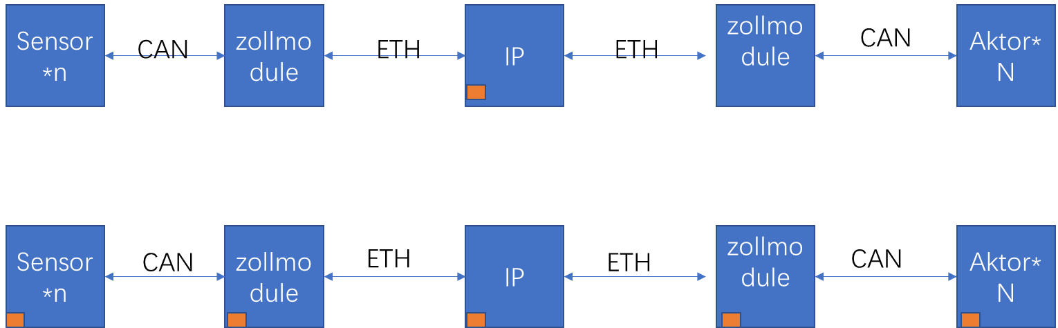

Here I configured the communication network with only parameter for buses. No Configuration about components

1. For components, I used APP4MC.